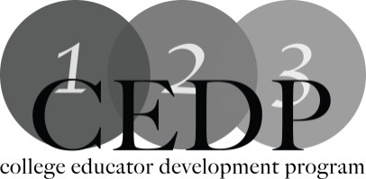

PLAGIARISM AND ACADEMIC INTEGRITY-Sue Prestedge

Workshop Description:
The question of plagiarism has been part of academia since time began. It becomes increasingly more important as students and professors have access to technology which provides instant information whether that information is correct or not.How do colleges in the Western Region deal with such problems? How do we as professors avoid violating Academic Integrity rules so we set an example for students.

Learning Outcomes:

- Identify academic issues as they relate to plagiarism and academic integrity
- Understand the principles of Academic integrity at their college with clear understanding of ramifications of violating such rules.

Facilitator: Sue Prestedge,Mohawk College
For more information: susan.prestedge@mohawkcollege.ca

Resources:
A useful site to use with students for the purposes of illustrating plagiarism:
http://www.plagiarism.org/
How to stimulate discussion about academic integrity in the classroom:
https://www.quinnipiac.edu/prebuilt/pdf/wac/database_fifty_ways_academic_integrity_0811.pdf

